Updating Education Through My Biz
1
You can access My Biz at https://compo.dcpds.cpms.osd.mil .

Login in using your Common Access Card (CAC), or if you haven¶t already done so, set up your CAC access. Click on „Login Help¶ toward the lower part of the screen to access the DCPDS Portal Quick Guide and follow the CAC Registration instructions beginning on page 2.

You can update your work email address, phone numbers, physical work address, handicap code, language information, ethnicity and race, emergency contact information, and education through My Biz, Update My Information.
The DoD CPMS My Biz Self-Service User Guide is available at http://www.cpms.osd.mil/HRBITS/selfservice/selfservice userguide.aspx
Then accept the Privacy Act Statement to continue
2

To add education, click the „Add¶ button
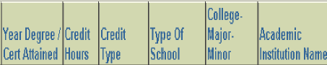
3

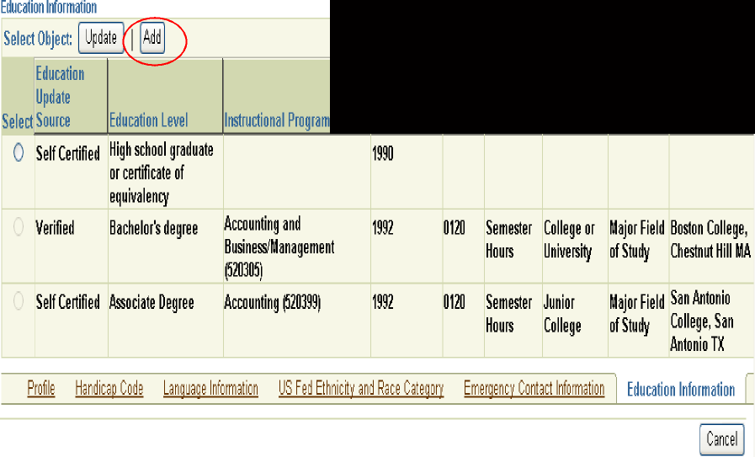

The add page displays where you will enter the new education information not yet documented in your record. Under Education Level, if you select Vocational/ Occupational Schools - certificate or diploma received (displays as Terminal Occupational program-cert of comp/diploma/equiv), Associate Degree, Bachelor¶s Degree and all higher education levels, i.e., Post-Bachelor¶s, etc., you must enter information in all the data fields. For other education levels the only data field you must complete is the Education Level.
4
For additional information on a data field, select the help icon . To obtain the list of information available for input or to search for specific education information select the flashlight located next to the data field.

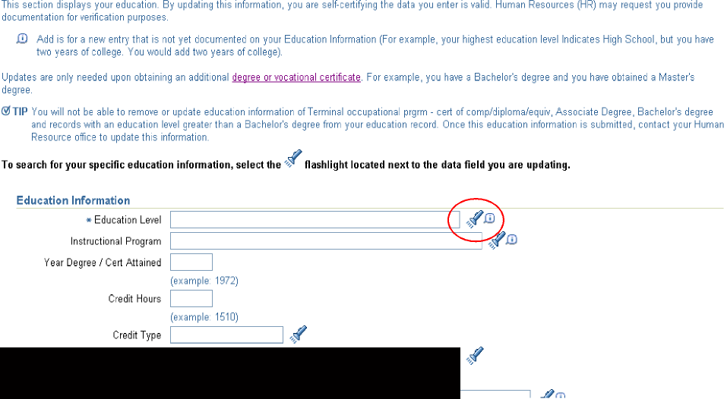

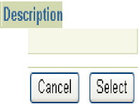
Below is the search screen that displays when you select the flashlight for „Education Level¶. To obtain a quick list of information available for input, select the „Go¶ button. To search for specific education information, enter the information in the search text field. You may use the wildcard „%¶ sign to conduct partial searches. We highly recommend you use the wildcard to conduct searches on long lists such as Instructional Program and Academic Institution Name. Wildcard search options are explained on the various search screens.

5

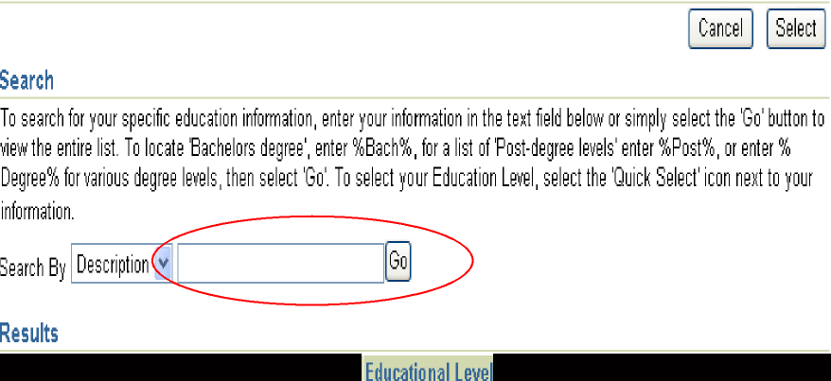

After you click the „Go¶ button, the first ten information choices will appear. Select the „Next 10¶ link, if available, to view more information. Once you find the information you want, select it by clicking on the „Quick Select¶ icon next to the information or click the radio button in the „Select¶ column and then click the „Select¶ button.
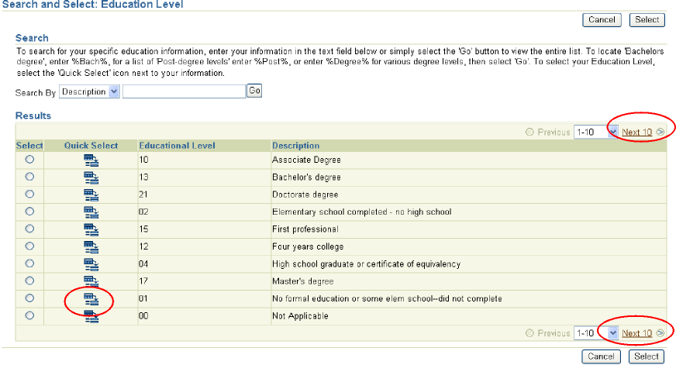
6
The selected information appears in the appropriate data field.

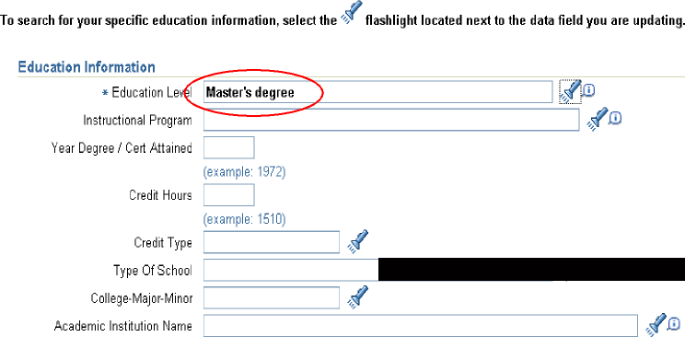

Some additional information on the education data fields:
7

If you select an „Education Level¶ of Vocational/Occupational Schools - certificate or diploma received (displays as Terminal Occupational program-cert of comp/diploma/equiv), Associate Degree, Bachelor¶s Degree and all higher education levels, i.e., Post-Bachelor¶s, etc., you must enter information in all the data fields.

Education Level – This data field is required for all updates or adds. There are 23 entries to choose from so you can either use the flashlight, then the Go button, then Next 10, or limit your search by typing in wildcards such as %degree%, %high%, %assoc%, or %college% in the text box before you hit the Go button.

Instructional Program – This data field is required only if you select Vocational/ Occupational Schools - certificate or diploma received (displays as Terminal Occupational program-cert of comp/diploma/equiv), Associate Degree, Bachelor¶s Degree and all higher education levels. There are 1361 entries to choose from. Once you select the flashlight, we recommend you narrow your search by typing in wildcards such as %Science%, %Law%, %Educ% in the text box before you click the Go button. If you find two entries for your instructional program that only differ in the number that displays, for example Accounting (520301) and Accounting (520399), use the Instructional Program Guide to help you select the correct program. Click on your overall instructional program and then scroll down till you find your specific instructional program. Select the instructional program with the same number. If you do not find an exact match for your instructional program or field of study, select the closest match.

Year Degree / Cert Attained - This data field is required only if you select Vocational/Occupational Schools - certificate or diploma received (displays as Terminal Occupational program-cert of comp/diploma/equiv), Associate Degree, Bachelor¶s Degree and all higher education levels. Type in the four digit year you received your degree or certificate. Do not enter a degree until you actually receive your diploma. If you are adding Post Bachelor¶s, Post Master¶s, Post-Sixth Year, Post-Doctorate enter the year you attained the hours.

Credit Hours - This data field is required only if you select Vocational/ Occupational Schools - certificate or diploma received (displays as Terminal Occupational program-cert of comp/diploma/equiv), Associate Degree, Bachelor¶s Degree and all higher education levels. Enter the total number of hours you have completed that apply to the Education Level and Credit Type.

Credit Type - This data field is required only if you select Vocational/Occupational Schools - certificate or diploma received (displays as Terminal Occupational program-cert of comp/diploma/equiv), Associate Degree, Bachelor¶s Degree and all higher education levels. There are 3 entries to choose from so click the flashlight and then Go to get the list.
Type of School - This data field is required only if you select Vocational/ Occupational Schools - certificate or diploma received (displays as Terminal Occupational program-cert of comp/diploma/equiv), Associate Degree, Bachelor¶s Degree and all higher education levels. There are 6 entries to choose from so click the flashlight and then Go to get the list.
8

College-Major-Minor – This data field is required only if you select Vocational/ Occupational Schools - certificate or diploma received (displays as Terminal Occupational program-cert of comp/diploma/equiv), Associate Degree, Bachelor¶s Degree and all higher education levels. There are 4 entries to choose from so click the flashlight and then Go to get the list.

Academic Institution Name – This data field is required only if you select Vocational/Occupational Schools - certificate or diploma received (displays as Terminal Occupational program-cert of comp/diploma/equiv), Associate Degree, Bachelor¶s Degree and all higher education levels. The list of institutions is limited to accredited institutions as only degrees from accredited institutions are accepted. There are 4612 entries to choose from. Once you select the flashlight, we recommend you narrow your search by typing in wildcards such as %TX% or %A&M% and click „Go¶. If %A&M% search does not provide the desired result, try %A & M% as spaces between letters or characters can produce different results. The city and state for some Academic Institutions reflects the location of the main office, not each separate location or satellite office. Note: „Not Applicable¶ is only used for Vocational/Occupational Schools – certificate or diploma received (displays as Terminal Occupational program-cert of comp/diploma/equiv).
9
To process your transaction and update DCPDS you must acknowledge this warning statement and electronically sign your transaction by selecting the „Process Transaction¶ button.
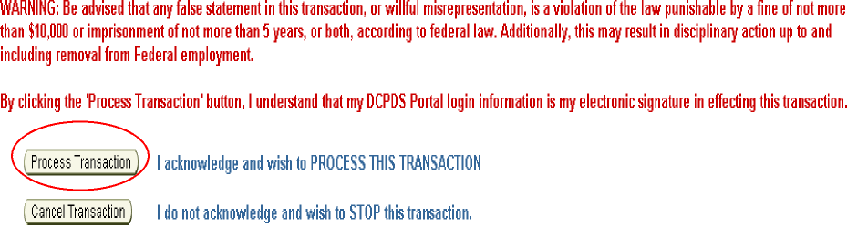
10
Once your transaction processes the confirmation page displays allowing you to print the education information you added.

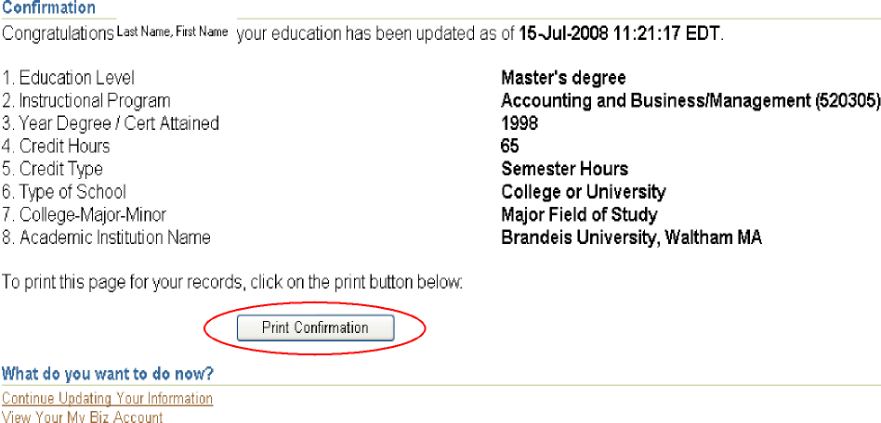

Click the „Continuing Updating Your Information¶ link to continue adding education information or click „View Your My Biz Account¶ to return to the DCPDS Home or Navigator screen.
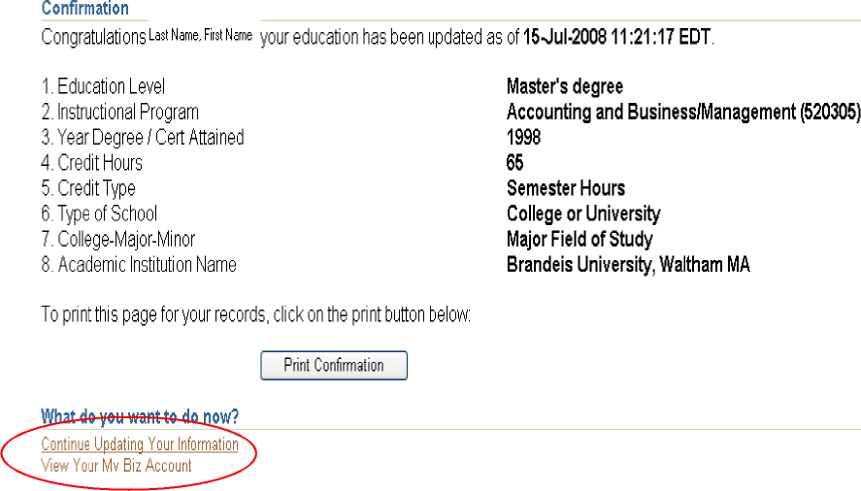
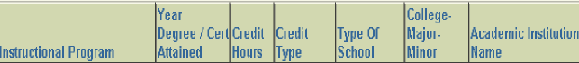
11
When viewing your education information, education information you „added¶ will indicate „Self Certified¶ in the Education Update Source column.

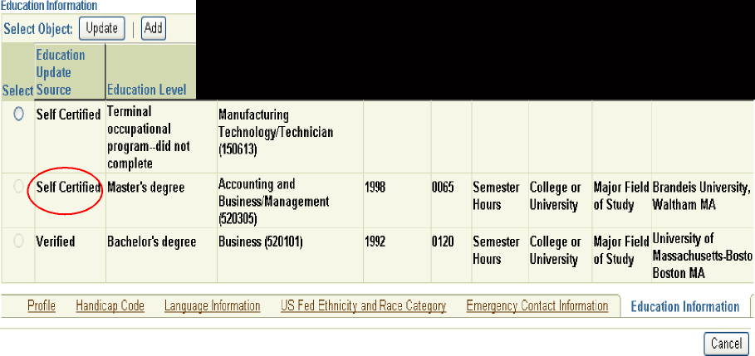

You can only update entries where the „Education Update Source¶ is Self Certified and the radio button under the Select column is not grayed out. You cannot update Self Certified entries where the Education Level is Vocational/Occupational Schools – certificate or diploma received (displays as Terminal Occupational program-cert of comp/diploma/equiv), Associate Degree, Bachelor¶s degree and all higher education levels. For example, if you input an education entry with an Education Level of Post Bachelor¶s you cannot later update the entry. As you earn additional hours you would „Add¶ a new entry. When adding the new entry you would enter the total number of hours you have completed that apply to that Education Level and Credit Type. You cannot update entries with a „Education Update Source¶ of Verified (input by personnel from a transcript) or blank (input by personnel from a resume without a transcript, or input by personnel prior to this self-service capability going live on 20 Jul 08).
12

For assistance in correcting an education entry that you cannot update through My Biz, please call the Total Force Contact Center, 1-800-525-0102, press 2, then press 3 and follow the prompts. If you are assigned at AFDW (Pentagon/11th Wing), Washington, D.C., Robins AFB, Georgia, Hill AFB, Utah, Tinker AFB, Oklahoma, Wright-Patterson AFB, Ohio, or are a Lab Demo employee at Brooks, Edwards, Eglin, Hanscom, or Kirtland Air Force Bases, please contact your local Civilian Personnel Flight/Civilian Personnel Section for assistance.
The „Update¶ page displays your existing education information as currently reflected in DCPDS. To update a data field, select the flashlight to search for the education information or if the flashlight is not available, type in the information. When searching for information, follow the same steps as you did for adding an education entry.
13

Once you have updated the appropriate data fields, select the „Submit¶ button.
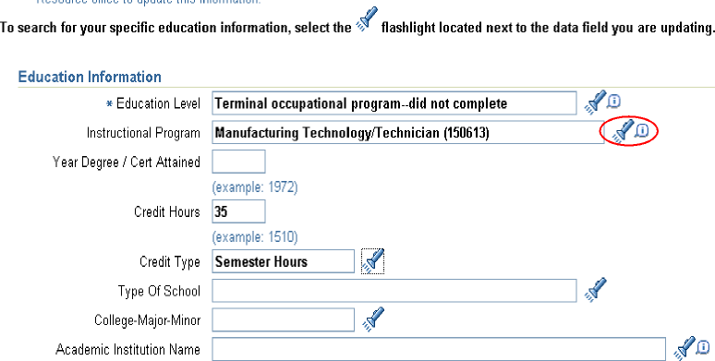
You will then complete the „Electronic Signature¶ just as you did when adding an education entry. Once your transaction processes the confirmation page displays allowing you to print your education information. Click the „Continuing Updating Your Information¶ link to continue updating education information or click „View Your My Biz Account¶ to return to the DCPDS Home or Navigator page.
For additional information on Updating Education through My Biz, contact your HRO office.

